Civil war in Somalia

UNSC Resolution: | 751
Date of adoption: | 24-Apr-1992
Operative paragraph: | 9
Demand number: | 751,0911

Sarah-Myriam Martin-Brûlé

Wording of demand
immediately cease hostilities and maintain a cease-fire throughout the country in order to promote the process of reconciliation and political settlement in Somalia

List of addressees of the demand

Government of Somalia, United Somali Congress Faction

Short-term compliance

Description of the addressee(s)’ conduct

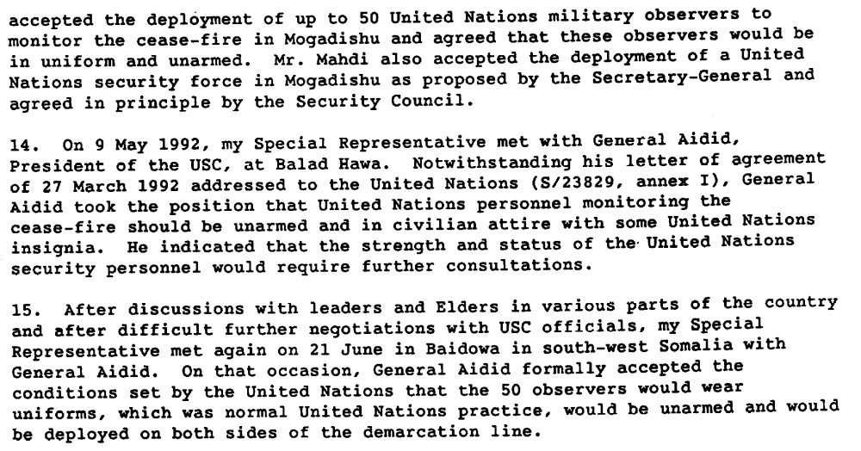

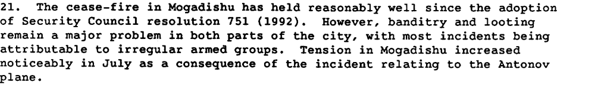

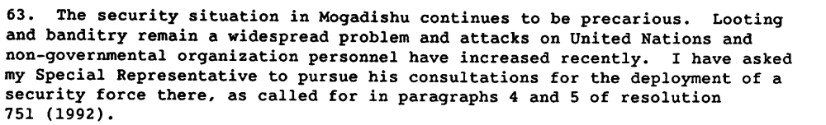
Report of the Secretary General on the Situation in Somalia, S 24343, 22 July 1992.

Assessment

Short-term compliance
No or marginal compliance (1) | X Medium low compliance (2) | Medium high compliance (3) | Full or almost full compliance (4)

Considerations underlying the assessment
There was an immediate compliance with the demands yet fighting and hostilities resumes within the six months following the resolution.

Medium-term compliance

Description of the addressee(s)’ conduct

“On January 1, 1993, serious fighting once again broke out, this time between the USC-Aideed forces and those of the Murusade clan, who were attempting to recapture territory that Aideed controlled. The Murusade forces shelled a troop cantonment of USC forces but were unsuccessful in taking control of the area. In late January 1993, there were clashes between the SNF under the command of General Morgan and SPM forces under the control of Col. Omar Jess in areas to the northwest of the southern port of Kismayu. On January 25, after warning Morgan's troops to retreat, U.S. Army helicopter gunships and Belgian ground forces attacked, destroying several of Morgan's heavy weapons and forcing him to retreat.4 U.S. forces attacked the SNF again on February 1, 1993

From December 8 to 10, 1992, prominent civilians of the Harti clan were killed by forces under the command of Colonel Ahmed Omar Jess and his Somali Patriotic Movement (SPM).It is thought that Jess, who is a member of the Ogaden, viewed Harti elders as a potential political threat once the foreign troops had arrived.5 «

Human Rights Watch. 1993.SOMALIA :Beyond the Warlords The Need for a Verdict on Human Rights Abuses March 7, 1993 Vol. V, Issue No. 2

Assessment

Medium-term compliance
X No or marginal compliance (1) | Medium low compliance (2) | Medium high compliance (3) | Full or almost full compliance (4)

Considerations underlying the assessment
Within the two years following the adoption of the demand, hostilities between the demand addressees endured and cease-fires did not uphold. The process of reconciliation and political settlement in Somalia did not succeed.

Depth of demand

Assessment

Level of depth of demand
Low depth of demand (1) | Medium depth of demand (2) | X High depth of demand (3)

Considerations underlying the assessment

Given the insecurity of the national setting, and in the absence of credible guarantees that the other demand addressees would also comply with the resolution, compliance with this demand jeopardize the survival of the demand addresses and hence their capacity to win power in the aftermath of the civil war.

“Sahnoun arrived in Mogadishu on May 4 1992. Mahdi was in Mogadishu and Aideed was consolidating his militia in the Kismayu area and in Bardera following Barre’s flights to Kenya. Resolution 751 was seemingly innocuous. But from Aideed’s point of view the resolution was potentially lethal. He had not given his agreement to the deployment of either contingent. He questioned in particular the purpose of deploying a security force. The forthcoming humanitarian emergency in the interriverine area was not then on the agenda. So what Aideed asked, was to be the function of a security force other than to assist Mahdi to restore law.”
John Drysdale. 1997. “Learning from Somalia”. Westview Press. p..121.

Level of confidence about coding decisions

Level of confidence about coding decision
Extremely high | X High | Moderate

Comments to IPI (if any)

